# ChatGPT

## Definition

**# Source**: **Windows ScreenShots (using Lightshot Program) From Site -> https://chatgpt.com/ at [8/27/2025]**

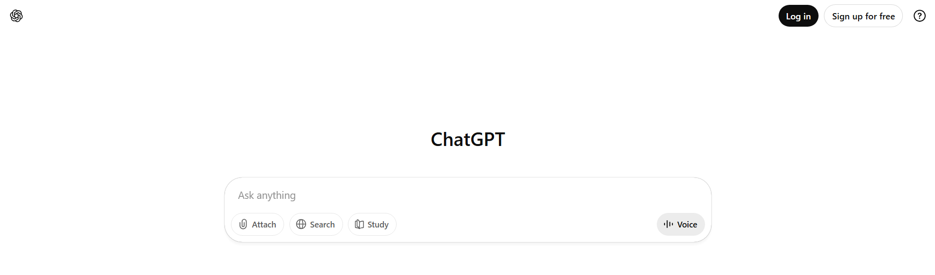

**# Source**: **Chatgpt (GPT-5-Standard) at [8/27/2025]**

**ChatGPT** is an **AI-powered conversational agent** developed by OpenAI. It uses advanced **natural language processing (NLP)** and machine learning to understand text input and generate human-like responses, assisting users in answering questions, generating content, and solving problems.

## Key Highlights

**# Source**: **Chatgpt (GPT-5-Standard) at [8/27/2025]**

* Developed by **OpenAI** using the **GPT (Generative Pre-trained Transformer)** architecture.
* Capable of **answering questions, writing text, summarizing, translating, and more**.
* Available through **web, API, and integrated applications**.
* Continuously improved with **successive GPT versions** (e.g., GPT-3, GPT-4, GPT-5).
* Widely used for **education, programming help, creative writing, and customer support**.

## Summary Table

**# Source**: **Chatgpt (GPT-5-Standard) at [8/27/2025]**

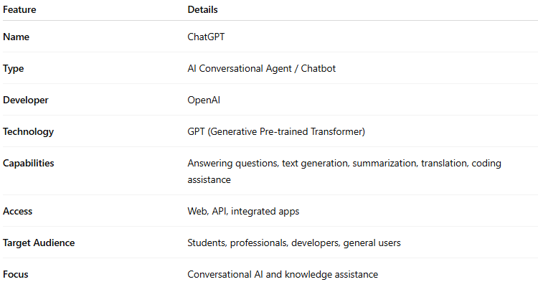

| **Feature** | **Details** |
| --- | --- |
| **Name** | ChatGPT |
| **Type** | AI Conversational Agent / Chatbot |
| **Developer** | OpenAI |
| **Technology** | GPT (Generative Pre-trained Transformer) |
| **Capabilities** | Answering questions, text generation, summarization, translation, coding assistance |
| **Access** | Web, API, integrated apps |
| **Target Audience** | Students, professionals, developers, general users |
| **Focus** | Conversational AI and knowledge assistance |